REQUEST FOR QUALIFICATIONS

Pike County Board of Commissioners

New Business Park Design, Planning & Other Related Services

1-12-2024

PIKE COUNTY BOARD OF COMMISSIONERS

MASTER PLAN AND ENGINEERING SERVICES FOR A NEW BUSINESS PARK

REQUEST FOR QUALIFICATIONS
The Pike County Board of Commissioners seeks a firm or team (hereinafter ‘firm’) to assist the County in design, engineering, permitting necessary to create a Master Plan for a new 238+/- acre mixed-use business park in Zebulon, Georgia. The work may also include design, bidding, and project management for the completion of infrastructure for the first phase or phases of the park.
The County seeks a qualified consulting firm to create a master plan and other services for a new proposed 238+/- acre mixed use business park, located between SR 18, County Farm Road, and Adams Street within the City limits of Zebulon, Georgia. The park is intended to serve governmental and non-governmental users. The successful candidate will work with the Pike County Board of Commissioners, City of Zebulon, Georgia Power/Atlanta Gas Light, State of Georgia (GDOT and potentially other agencies) and other regulators and utility providers as may be identified through a multi-step planning process that will include the following elements:
- A visioning process that will establish major plan objectives, goals, and policies for the preparation of the master plan.
- Preparation of any required environmental studies, wetlands delineations, flood studies or other work needed to clearly identify land available for development within the site.
- Development of preliminary engineering and cost estimates for infrastructure to serve the industrial park to include roads, utilities and other amenities as may be identified.
- Prepare several build out scenarios (maps) showing build-out utilizing various lot sizes, including the property to be allocated for a government complex.
- Preparation of exhibits for necessary zoning changes within the City of Zebulon.
- Preparation of preliminary drawings and construction drawings for the first phase of the development and any required utility extensions
- Providing permitting services for the first phase and bid phase management for the selection of a contractor for the improvements for the first phase.
- Provide construction coordination/owners representation services for the first phase of improvements.
Firms submitting a response to the RFQ will be asked at a minimum to state their qualifications, understanding/experience relating to the project and offer their methodology for meeting the desired outcomes of the project. Firms should specifically outline their experience working on master planning for industrial development.

SCHEDULE
RFQ Released January 12th, 2024
Pre-Submittal Site Visit January 26th, 2024
Cut off for Questions February 16th, 2024
Submittals are Due March 1st, 2024 4:00 PM
Notify Short Listed Firms March 6th, 2024
Interviews (If Needed) TBD
Notice of Preferred Candidate March 8th, 2024
Scope of Work/Schedule/Budget March 11th-12th, 2024
Presentation to Board of Commissioners March 13th, 2024
Contract Execution TBD

Questions may be submitted by e-mail to Brandon Rogers at countymanager@pikecoga.gov through the cut- off date. All attempts will be made to respond to all parties who have requested a copy of the RFQ, but it is the responsibility of the parties to ensure they have provided a primary point of contact and that the point of contact information provided is correct.

DESIRED QUALIFICATIONS
  - Knowledge and experience in the preparation of master plan development for heavy and light industrial parks.
  - Knowledge and experience of applicable regulatory and legal requirements.
  - Knowledge and experience in working with the various existing partners.
  - Proven track record of customer service and responsiveness to clients in a high contact setting.
  - Fostering partnerships between various organizations to support development.

BACKGROUND
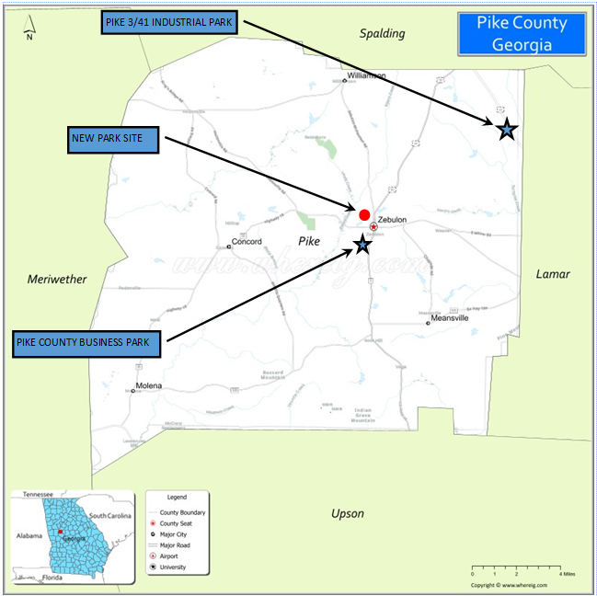
Pike County, Georgia is rapidly growing with the continuing expansion of the greater Atlanta area. Pike County’s population has increased 9,952 persons from 1980 to 2020 (111% increase). Zebulon serves as the county seat of Pike County and is home to the majority of the commercial and industrial activity in the County. The City of Zebulon operates a public water system and one of the two sewer systems in the County. The City has adequate capacity for the proposed park and can easily supply drinking and process water needs for the new park.
New Business Park
The Pike County Board of Commissioners recently acquired 238 acres of land in the City of Zebulon. The County has identified a need to build a new governmental complex for public safety and general government operations and the new Business Park has been identified as the location for this complex. The Business Park will be designed to accommodate the governmental complex and the infrastructure and utility extensions needed for the complex will be incorporated into the master plan and subsequent construction drawings for the Park. Figure 1 shows the location of Pike County within the State of Georgia and the current and proposed business park locations.
Site
Figure 1 – Pike County
The land is currently a mixture of forest and open pasture with some old agricultutal buildings within the proeprty (See Figures 2 and 2A). The property is located less than a mile from the Courthosue Square and has access to State Route 18, a major east west freight corridor between LaGrange and Forsyth/I-75, as well as US19, a four lane highway that connects the community with Atlanta and the Atlanta Airport. The proeprty is adjacent to the City of Zebulon’s wastewater treatment facility. Seveal sanitary sewer outfalls cross through the property, making sewer connections uncomplicated. The site is also bounded by two 10” water mains. Natural gas is available along SR 18 and a Georgia Power transmission line crosses through the property.
The Pike County Development County has completed a Preliminary Feasibility Study prepared by McKinley Environmental and Engineering Consultants. The Board of Commissioners also authorized a Phase 1 ESA prepared by Applied Environmental Science. Both documents indicated that there are no significant impediments to developing the property for the intended use. These documents will be made available to the entity selected for this scope of work.
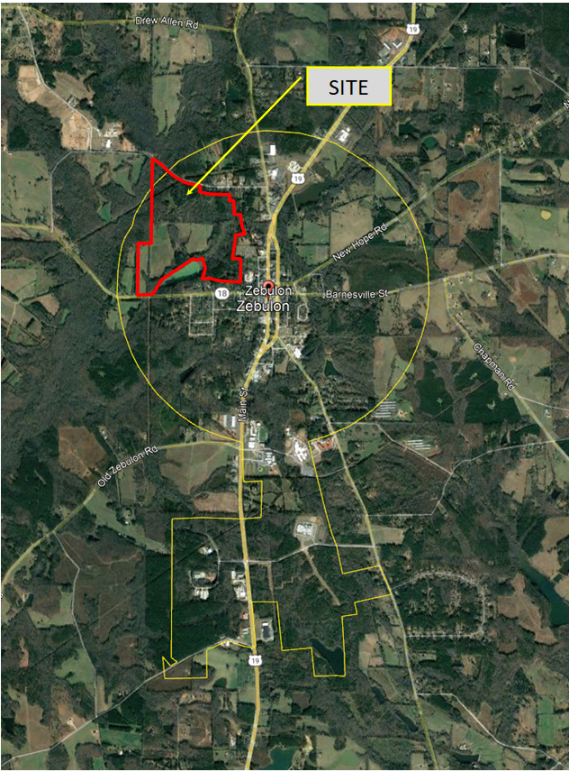
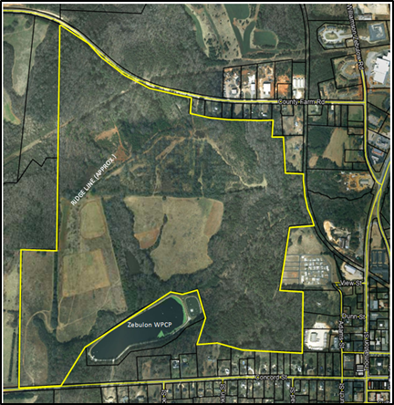
Figure 2A - New Business Park Site - Zoomed In

Figure 2 - New Business Park Site
Pike County is seeking to replicate the success of the two existing business parks in the County by attracting new small and medium sized businesses wishing to relocate and/or expand. By preparing a masterplan and the subsequent engineering documents, the Development County and Pike County will be able to maximize the property for development while providing buffers for the adjacent residential neighborhoods.

HOW TO SUBMIT
Interested firms should submit the information electronically or in person to the following address no later than 4:00 PM March 1st, 2024.

Angela Blount County Clerk
ablount@pikecoga.gov
331 Thomaston Street
Zebulon, GA. 30295

Submittal Contents
- A cover letter explaining how your team’s capabilities are best suited to assisting the Board of Commissioners
- Samples of other successful projects.
- Qualifications of firm principals that will be assigned to this project.
- Provide names, phone numbers and contact people at three organizations for whom you have performed similar work.

Submittal Evaluation
The review panel will include members/employees of the Pike County Board of Commissioners. Firms will be rated on qualifications (both engineering/design and fostering collaboration to support development), previous work experience, team members and the quality of the presentation of this information. Each element will be equally weighted. The panel will score independently and meet to determine the top two or three candidates, who may then be asked to an interview.

Interview Presentation
Firms/teams selected for interviews will be asked to present a brief synopsis of their qualifications and previous projects they have worked on. Further questions will be developed and provided prior to the interview. The interview panel will likely include the members of the Board of Commissioners. Firms will be rated based on response to questions, qualifications to perform the work, previous work, and overall presentation. Criteria will be equally weighted.

Contract
The winning firm will be expected to enter into a Professional Service Agreement with Pike County. The contract will be a cost reimbursement with an agreed maximum. The winning firm will be required to provide a breakdown of their fee.

Addenda
As the County determines it is appropriate, it will issue addenda to this RFQ. Each firm shall provide the County with contact information for receipt of such addenda. Any applicant who downloads the RFQ from http://www.pikecoga.com or otherwise obtains this document, must send an e-mail to Brandon Rogers at countymanager@pikecoga.gov with the party’s contact information in order to receive an addendum. The County is not responsible for e-mail delivery failure for any reason. It shall be conclusively presumed that the applicant did, before submitting a Response to the RFQ read all addenda, posted decisions, and other items relevant to the qualifications. All addenda shall be acknowledged by the firm and returned to the County with the submittal document.

OPEN RECORDS ACT
Documents submitted in response to this RFQ are subject to the Georgia Open Records Act. If the proposer believes that any information, data, process or other material in its proposal constitutes trade secrets, privileged information, or confidential commercial, financial, geological, or geophysical data, then the proposer should mark those items as confidential or proprietary and provide a list of those items with specificity as to the page and paragraph and on what basis it believes the material is confidential or proprietary. The County is not bound by the proposer’s determination as to whether materials are subject to disclosure under the Open Records Act.

PROPOSAL PREPARATION, CONSULTANTS COSTS AND EXPENSES
The County is not liable for any costs or expenses arising out of the preparation of the firm’s submittal. If selected, the firm may not include any of these costs or expenses as part of its fee, rates, or charges for performing work under the Contract. Proposals should be prepared simply, economically, providing straightforward, concise description of proposer’s ability to satisfy the requirements of the RFQ. Submittal of technical literature, display charts, or other supplemental materials are the responsibility and within the discretion of the proposer.
The successful firm will supply its own materials and will provide and pay for all labor, supervision of its employees and agents, travel, insurance, vehicles, materials, and tools necessary to provide services under the resulting contract.
The County reserves the right to reject any or all submittals, waive informalities, and make the award in the best interest of the County. The County reserves the right to contact a firm for clarifications of its proposal during the evaluation process. The successful firm should be prepared to accept this RFQ for incorporation into an AGREEMENT resulting from this RFQ. It is also understood that the proposal will become part of the official contract file.

